**Exp No 4 and 5**

4,5. Practicing DDL Commands (Data Definition Language)

• Create table command

• Alter table command

• Truncate table command

• Drop table command

1.Create table command :

*create table student(ID int, Name varchar(45), branch varchar(45));*

*desc student;*

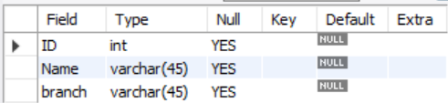



2.Alter table command

*alter table student add email varchar(100);*

*desc student;*

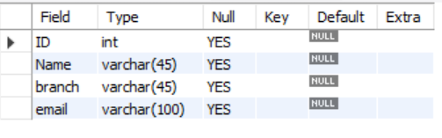



3. Truncate table command

*truncate table student;*



4. Drop table command

*drop table student;*

